54*3W LED PAR

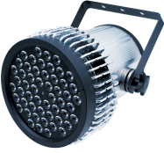

Read the instructions carefully before use

essential parameter ：
Rated power: 150W.
Voltage/frequency: AC110-240V/50-60HZ wide voltage switching power supply, can meet the requirements of different countries in the world for voltage and frequency. It adopts high-tech constant current power board, stable output voltage and current, long working life, strong anti-interference ability.
Channels: 8 and 4 control channel modes.
Control mode: divided into DMX mode, random mode, self-walking mode and voice control mode.
Light source: high quality, high brightness brand LED light source, 3W RGBW full color.
Beam Angle: Optical lens, standard 25 degrees (optional), full, uniform, bright, pure color.
Mixing effect: the uniform RGBW infinite mixing system, which can form a very rich color. Each color can be controlled by DMX512 signal alone, and the mixing between colors can produce a colorful effect.
Special functions: built-in a variety of lighting effect programs, sound control synchronous operation.
Frequency flash: high speed electronic frequency flash can be up to 1-25 times/second or random frequency flash.
Light dimming: the total light dimming channel can control the brightness change and light closure of 5 main colors at the same time, and there is no flicker or jitter phenomenon.
Heat dissipation protection: high heat dissipation performance aluminum special self-cooling radiator without fan, high quality full pressure stretching aluminum shell, so that the heat of the lamp body is discharged in time, always kept in the predetermined temperature range, with temperature control protection function, silent and dust-free can extend the service life.
Design: beautiful and robust, with design patent, imitation must be investigated.
IP protection level: IP20;
Product size: 310*310*270 mm Product size: 310*310*270 mm
Net weight: 5 Kg

1. Display menu and instructions
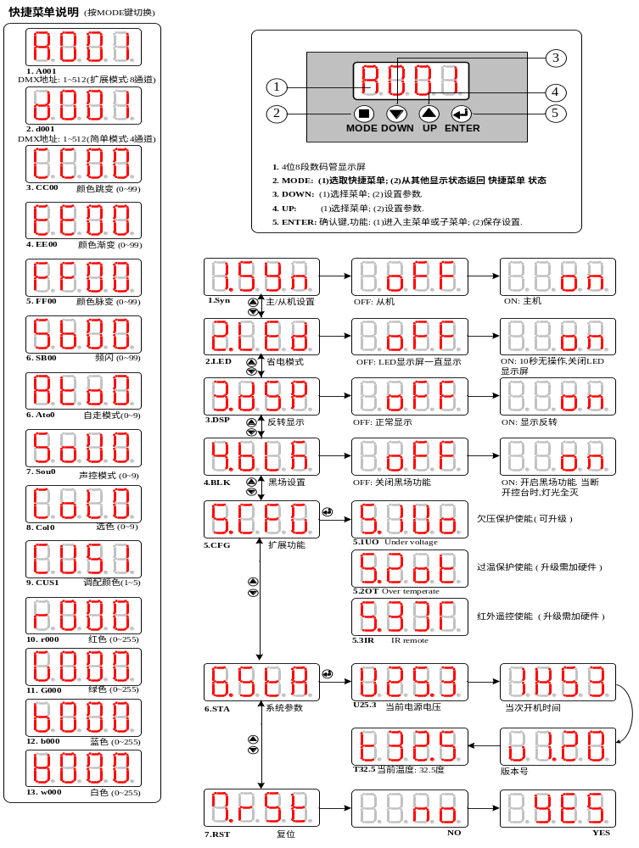
2.DMX channel table
(1) A001: Extended mode channel table
channel | Channel name | numeric value | explain
1 | aiming | 0~255 | General dimming
2 | stroboflash | 0~255 | From slow to fast flicker
3 | Effect / mode | 0~5 | Manual color adjustment (red, green, blue......)
3 | Effect / mode | 6~50 | Gradual color change
3 | Effect / mode | 51~100 | Gradual color change
3 | Effect / mode | 101~150 | Twitch to change color
3 | Effect / mode | 151~200 | Automatic mode (ignoring data from other channels except this channel and speed channel)
3 | Effect / mode | 201~255 | Voice-activated mode (ignoring data from other channels except this channel and speed channel)
4 | velocity | 0~255 | When [Effect/Mode] is enabled, adjust the speed of color change or self-walking
5 | red | 0~255 | Linear dimming
6 | green | 0~255 | Linear dimming
7 | blue | 0~255 | Linear dimming
8 | white | 0~255 | Linear dimming

- D001: Simple mode channel table
channel | Channel name | numeric value | explain
1 | red | 0~255 | Linear dimming
2 | green | 0~255 | Linear dimming
3 | blue | 0~255 | Linear dimming
4 | white | 0~255 | Linear dimming

