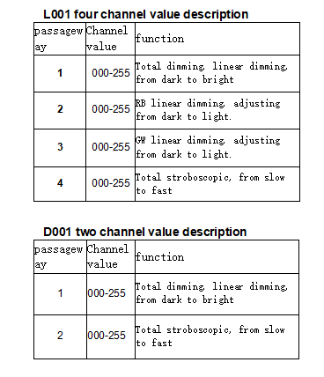

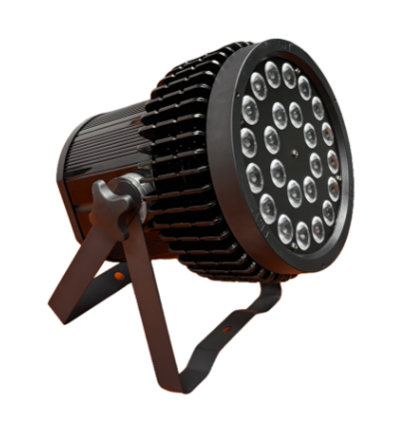

MANUAL DEL USUARIO

Por seguridad y una mejor operación, por favor lea este manual cuidadosamente antes de usar y operar este equipo, para que no ocurra ninguna lesión personal ni daño a laluminaria.

Specifications

. Input Voltage: 110-240V AC, 50-60 Hertz
. Max Power Consumption: 360W
Light Source
. 24 x 15W LEDs(R,G,B,W)
Optical
. Lens Angle: 25° / 40°
Control Singal
. Protocol USITT DMX-512
. DMX Channels: 5/9
Cooling Method: Aluminum radiator
IP rate: IP20
Net Weight：4kgs
Dimension: 530×530×400mm / 4 pcs
Aviation box packaging

Menu

passageway | Channel value | function
1 | 000-255 | Total dimming, linear dimming, from dark to bright
2 | 000-255 | Total stroboscopic, from slow to fast
3 | 0-29 | Dimming
3 | 30-34 | Not bright
3 | 35-39 | Light bead R is on
3 | 40-44 | Light bead G is on
3 | 45-49 | Light beads R and G are on
3 | 50-54 | Light bead B is on
3 | 55-59 | Light beads R and B are on
3 | 60-64 | Light beads g and B are on
3 | 65-69 | Light beads R, G, B, on
3 | 70-74 | Light bead w on
3 | 75-79 | Light beads R and W are on
3 | 80-84 | Light beads g and W are on
3 | 85-89 | Light beads R, G and W are on
3 | 90-94 | Light beads B and W are on
3 | 95-99 | Light beads R, B and W are on
3 | 100-104 | Light beads g, B and W are on
3 | 115-109 | Light beads R, G, B and W are on
3 | 110-139 | Gradual change
3 | 140-169 | Pulse change
3 | 170-179 | Lamp bead R → g → B → w circulating light
3 | 180-189 | Lamp bead w → B → G-R cycle lamp
3 | 190-199 | Lamp beads R, G, and B, w cycle light
3 | 200-209 | Lamp beads R, W and G, B cycle running lamp
 | 210-219 | Lamp beads R, B, and G, W, cycle lamp
 | 220-229 | Lamp beads R, G to g, B to B, w to W, R cycle light
 | 230-239 | Lamp beads R, G, B to g, B, w to B, W, R, cycle light
 | 240-249 | Lamp bead r-g-b-w circulation
 | 250-255 | Voice control
4 | 000-255 | Channel 3 function speed, from slow to fast
5 | 000-255 | R linear dimming, adjusting from dark to light.
6 | 000-255 | G linear dimming, adjusting from dark to light.
7 | 000-255 | B linear dimming, adjusting from dark to light.
8 | 000-255 | W linear dimming, adjustable from dark to light.

