7x60w 4in1 Bee Eye

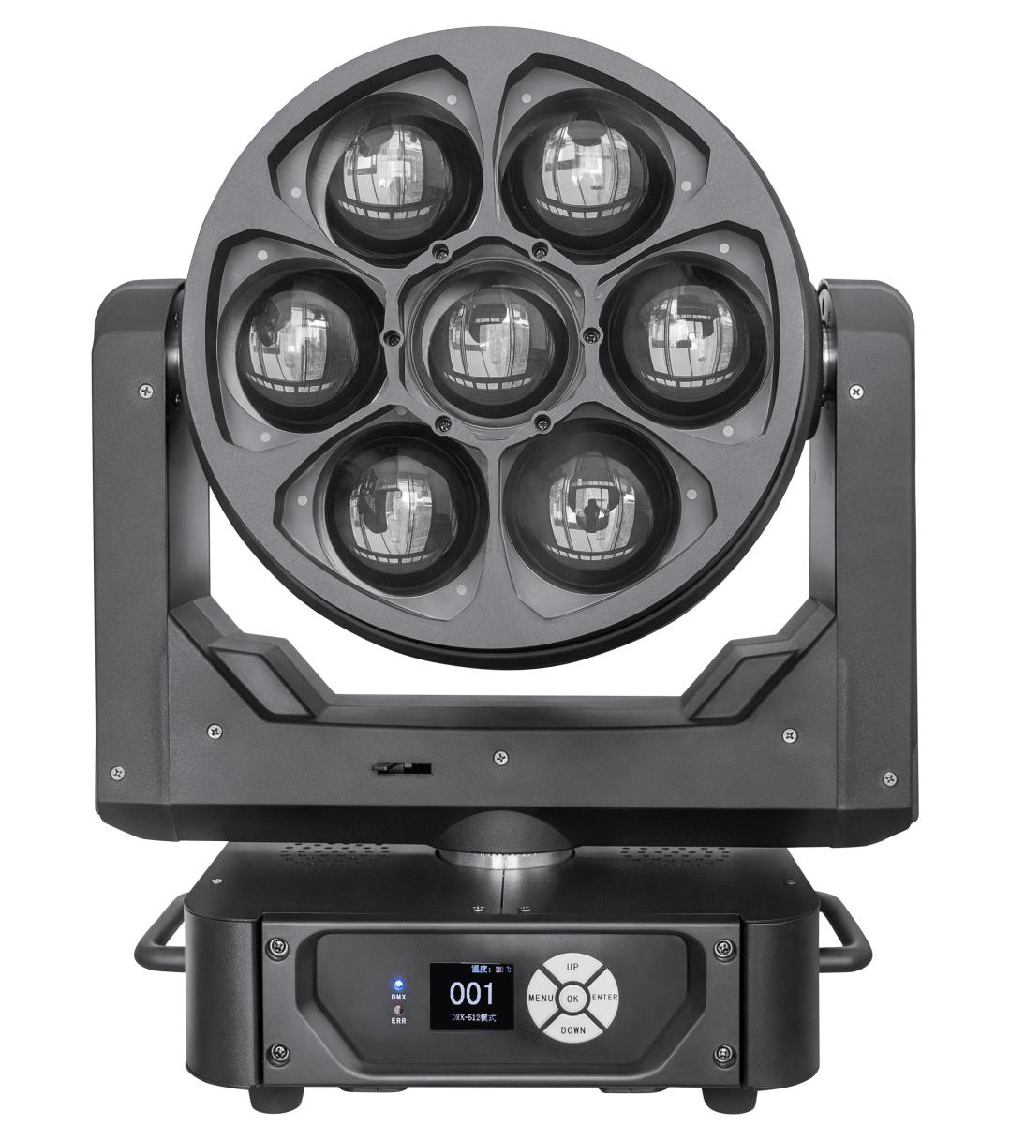

PLEASE READ THIS CAREFULLY BEFORE USE

Skill parameters
Light Sources: 7x60W RGBW Original LED
Power Voltage: AC 100-240V, 50/60Hz, 500w
Single LED power: 60W
Color: RGBW automatic correction 16.7 million pixels
Electronic dimmer:0～100% linear

Control
DMX Channel: 23/35/51 Channel
Control Modes: DMX512
Software Upgrade: Firmware update via DMX link

Pan/Tilt

Pan/Tilt: 540°

Construction
Display: LCD Display
Data In/Out socket: 3-pin XLR sockets Power Socket: Powercon in/out
Protection Rating: IP20

Features

Motorized liner zoom system,
zoom range: 4.5°~45° Outstanding color macro effect,CTO,Kaleido effects,led single controlled
Dimmer: 0~100% smooth dimming Variable strobe effects
Fast, quiet operation and flicker free
/ 270° Pan/Tilt Resolution: 16bit

23 | reset | 0-199 | invalid
23 | reset | 200-205 | Reset after 5 seconds
23 | reset | 206-255 | invalid
35 CH | Channel | DMX Value | Function
1 | red | 0-255 | Red dimmer
2 | Red fine | 0-255 | Red dimmer fine
3 | green | 0-255 | Green dimmer
4 | Green fine | 0-255 | Green dimmer fine
5 | blue | 0-255 | Blue dimmer
6 | Blue fine | 0-255 | Blue dimmer fine
7 | white | 0-255 | White dimmer
8 | White fine | 0-255 | White dimmer fine
9 | CT | 0-255 | Linear CT control
10 | Color Macro | 0-255 | Color Macro function
11 | strobe | 0-3 | off
11 | strobe | 4-103 | Synchronous strobe slow-fast （1HZ-25HZ）
11 | strobe | 104-107 | on
11 | strobe | 108-207 | Divide strobe from slow-fast （1HZ-25HZ）
11 | strobe | 208-212 | on
11 | strobe | 213-225 | Random strobe in low speed
11 | strobe | 226-238 | Random strobe in middle speed
11 | strobe | 239-251 | Random strobe in high speed
11 | strobe | 252-255 | on
12 | dimmer | 0-255 | Linear dimmer from dark-bright
13 | Dimmer fine | 0-255 | Dimmer fine
14 | pan | 0-255 | pan
15 | Pan fine | 0-255 | Pan fine
16 | tilt | 0-255 | tilt
17 | Tilt fine | 0-255 | Tilt fine
18 | function | 0-255

19 | reset | 0-199 | invalid
19 | reset | 200-205 | Reset after 5 seconds
19 | reset | 206-255 | invalid
20 | zoom | 0-255 | zoom
21 | Lens rotating | 0-127 | 0~60 degree
21 | Lens rotating | 128-191 | Forward limitless rotate
21 | Lens rotating | 192-255 | Reverse limitless rotate
22 | pattern | 0-255 | Pattern rotate
23 | Pattern speed | 0-255 | Pattern speed
24 | Pattern effect fade | 0-255
25 | Pattern effect R | 0-255
26 | Pattern effect G | 0-255
27 | Pattern effect B | 0-255
28 | Pattern effect W | 0-255
29 | Pattern dimmer | 0-255 | Pattern 0-100% dimmer
30 | Background dimmer | 0-255 | Background 0-100% dimmer
31 | Pattern transition | 0-255
32 | Pattern angle | 0-255 | Pattern design
33 | Prospect strobe | 0-255 | Prospect strobe（with 11 chs）
34 | Background strobe | 0-255 | Background strobe（with 11 chs）
35 | Background selection | 0-255
51 CH | Channel | DMX Value | Function
1 | X | 0-255 | 0-540 degree
2 | X fine | 0-255 | 16 bit
3 | Y | 0-255 | 0-205 degree
4 | Y fine | 0-255 | 16 bit
5 | XY speed | 0-255 | Fast-slow
6 | zoom | 0-255 | Small-big
7 | rotating | 0-127 | 0~60 degree
7 | rotating | 128-191 | Forward fast-slow

7 | rotating | 200-255 | Reverse slow-fast
8 | dimmer | 0-255 | Dark-bright
9 | strobe | 0-3 | on
9 | strobe | 4-200 | Synchronous strobe slow-fast
9 | strobe | 201-215 | Random strobe in low speed
9 | strobe | 216-234 | Random strobe in midlle speed
9 | strobe | 235-255 | Random strobe in high speed
10 | R dimmer | 0-255
11 | G dimmer | 0-255
12 | B dimmer | 0-255
13 | W dimmer | 0-255
14 | CT | 0-255 | Linear CT control
15 | Wash | 0-255
16 | Static effect | 0-255 | 5 no. One effect
17 | Dynamic effect | 0-255 | 5 no. One effect
18 | Dynamic effect speed | 0-127 | Forward fast-slow
18 | Dynamic effect speed | 128-255 | Reverse slow-fast
19 | Background R | 0-255 | Dark-bright
20 | Background G | 0-255 | Dark-bright
21 | Background B | 0-255 | Dark-bright
22 | Background W | 0-255 | Dark-bright
23 | reset | 0-199 | invalid
23 | reset | 200-205 | Reset after 5s
23 | reset | 206-255 | invalid
24 | R1 LED dimmer | 0-255 | R1 LED dimmer
25 | G1 LED dimmer | 0-255 | G1 LED dimmer
26 | B1 LED dimmer | 0-255 | B1 LED dimmer
27 | W1 LED dimmer | 0-255 | W1 LED dimmer
… | … | …… | ……
48 | R7 LED dimmer | 0-255 | R7 LED dimmer
49 | G7 LED dimmer | 0-255 | G7 LED dimmer
50 | B7 LED dimmer | 0-255 | B7 LED dimmer
51 | W7LED dimmer | 0-255 | W7 LED dimmer

Channels List

23 CH | Channel | DMX Value | Function
1 | X | 0-255 | 0-540 degree
2 | X fine | 0-255 | 16 bit
3 | Y | 0-255 | 0-205 degree
4 | Y fine | 0-255 | 16 bit
5 | XY speed | 0-255 | Fast-slow
6 | zoom | 0-255 | Angle from small-big
7 | rotating | 0-127 | 0~60 degree
7 | rotating | 128-191 | Antiwise fast-slow
7 | rotating | 200-255 | Forward slow-fast
8 | dimmer | 0-255 | From dark-bright
9 | strobe | 0-3 | on
9 | strobe | 4-200 | Synchronous strobe from slow-fast
9 | strobe | 201-215 | Random strobe in low speed
9 | strobe | 216-234 | Random strobe in middle speed
9 | strobe | 235-255 | Random strobe in high speed
10 | R dimmer | 0-255 | From dark-bright
11 | G dimmer | 0-255 | From dark-bright
12 | B dimmer | 0-255 | From dark-bright
13 | W dimmer | 0-255 | From dark-bright
14 | CT | 0-255 | Linear CT control
15 | wash | 0-255 | Inner color gradual change
16 | Static effect | 0-255 | 5 no. One effect
17 | Dynamic effect | 0-255 | 5 no. One effect
18 | Dynamic effect speed | 0-127 | Forward from fast-slow
18 | Dynamic effect speed | 128-255 | Reverse from slow-fast
19 | Background R | 0-255 | Dark-bright
20 | Background G | 0-255 | Dark-bright
21 | Background B | 0-255 | Dark-bright
22 | Background W | 0-255 | Dark-bright

