1940 waterproof lamp
instructions

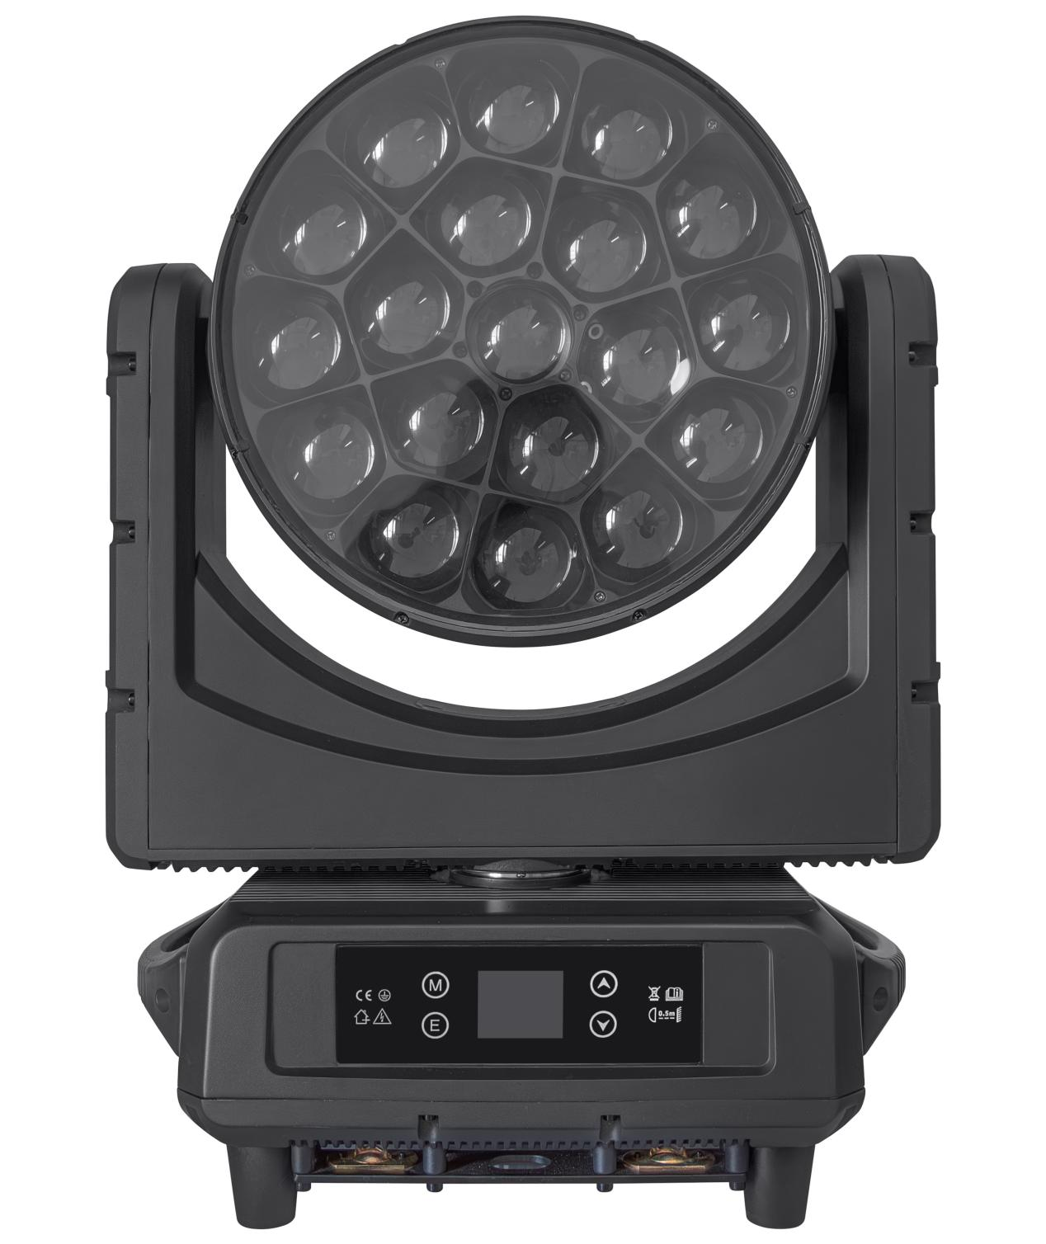

Please keep the instruction manual properly
1. Remove the packing
For the correct and safe use of this product, please read the instructions carefully before installing and using this product. This instruction contains important installation and application information, and please strictly follow the operation steps in the instructions when installing and operating the product. At the same time, please keep this instruction properly.

The 1940 waterproof lamp is designed and produced in strict accordance with CE standards, and conforms to the international standard DMX512 signal protocol. It can be used for control alone or online. It has the characteristics of fast rotation, low noise and powerful functions, and is suitable for small and medium-sized concerts, theaters, studios, nightclubs and bars.

Please be careful to remove the package. After removing the package, check whether the product is damaged during transportation and check whether the following contents are complete.

1940 waterproof lamp----1 signal line----1 1940 waterproof lamp----1 signal line----1
Instruction manual----1 power cord----1 Instruction manual----1 power cord----1

2. Safety instructions

pay attention to ！
Please be careful before operating this product. This product is a high voltage product. If you touch the wire, you may be electrocuted!

This product is in perfect condition before leaving the factory. To maintain its integrity and ensure safe operation, users should follow the safety instructions and warnings provided in this manual. Important: Any damage caused by not following this manual is not covered under warranty. The supplier is not responsible for any issues arising from non-compliance with the manual. If the product has been exposed to extreme temperature fluctuations (such as after transportation), do not immediately connect it to power, as condensation from temperature changes can damage the product. Wait until the product has returned to normal operating temperature before using it.
This product can be used in the voltage range of 90-240V, which is for indoor use. Please ensure that the ground voltage is not higher than the range that the product can withstand!! The power plug must be plugged into a class I socket with good protection. The green or tea-colored conductor must be grounded.
Please check the power cord of this product regularly. Ensure that the power cord is not folded or damaged, and do not connect it to other wires! Pay special attention when connecting the power cord or related wires. Unplug the power cord before using this product or cleaning.
Before using the product, please familiarize yourself with the operation function of the product. Please do not let children or unprofessional personnel touch the product.
Please do not shake this product. Do not use brute force when installing or operating the product. Do not allow unprofessional personnel to operate the product. Most damage is caused by unprofessional operation.
The product is not equipped with relevant maintenance parts. The maintenance and repair of the product can only be carried out by professionals!
Please do not change this product without authorization, otherwise the product may be damaged, so the damage caused is not covered by the warranty. In addition, unprofessional operation may lead to short circuit, burns or electric shock, etc.

3. Operation instructions

--This product is a shaking dyeing beam lamp, used to create dyeing performance effects.
--If the product has been exposed to a large temperature difference (for example, after transportation), do not start the product immediately, because hot shrinkage will damage the product. Please wait until the equipment reaches normal room temperature before starting the product.
--Pay attention to shockproof. Avoid strong collision during installation.
--Please do not lift the entire product through the lamp head, because the mechanical damage of the equipment may be caused.
--When selecting the installation location, make sure that the product is not exposed to overheating, too wet or dusty places. Do not place any wires on the ground, otherwise you may be at risk of electric shock.
--Before installing the product, make sure that the installation point is safe
--Secure the product with a safety rope and check all screws for correct installation
--Please ensure that the lens is in good condition. When the lens is damaged or scratched, please replace the lens.
It is recommended that the product be operated by a technician familiar with the product. Non-technical personnel are prohibited from operating this equipment, because many losses are caused by non-professional operation.
--Please keep the packing materials properly in case of secondary transportation.
--Do not change the product without the guidance of the manufacturer or distributor.
--Any equipment failure caused by not operating the equipment according to the instructions is not covered by the warranty. And any accident caused by short circuit, injury, electric shock, ultraviolet light, bulb explosion and so on are not covered by the warranty.

4. Product hanging and installation

Note: For safety, please hang the product away from aisles, seating areas, or areas accessible to people
Before hanging this product, please ensure that the installation point can withstand 10 times the weight of this product.
The product must be installed with double protection devices, such as safety ropes.
When hanging, removing or repairing this product, do not stand under the installation point.
Please ensure that the product should be installed at least 0.5 meters away from flammable materials.
Please remember to use a safety rope as a safety guarantee in case of accidents when fastening the lock.

Hanging point: The top hanging requires the installation personnel to be experienced, including calculating the load requirements, using the installation materials, and periodically checking the safety status of the installation materials and products. If you lack this knowledge, please do not try to install by yourself. If the operation is not correct, it may lead to serious consequences such as personal injury.
Before the product is powered on, please be sure to complete all required hanging and installation steps.
Quick lock hanging: This product has a specially designed professional hanging part at the bottom, including quick lock hanging part and safety rope hanging point (please refer to the figure below).
When hanging the product on the truss, please remember to use the appropriate quick lock, fix it at the quick lock hanging position of the product, and hang it with M10 screws. For further safety, install the safety rope at the bottom of the product and fix it on the truss.
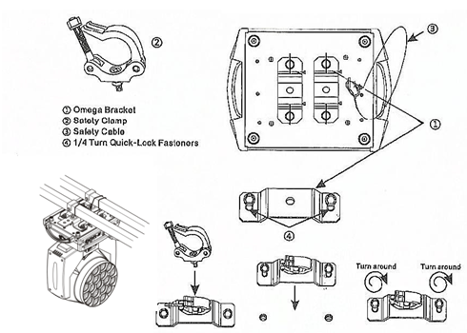
No matter which type of suspension you choose, please remember to use a safety rope. The bottom of the product is equipped with a special safety rope hanging point, please refer to the picture above, and please remember to use the special safety rope hanging point, do not install the safety rope on the handle position.

5.DMX-512 linkage

Please connect the male XLR connector of this product to the controller's signal output port, and the female XLR connector to the signal input port on the back panel of this product. You can connect multiple units in series, and the signal cable must be three-core, shielded, and equipped with XLR input and output connectors. Please refer to the following diagram.
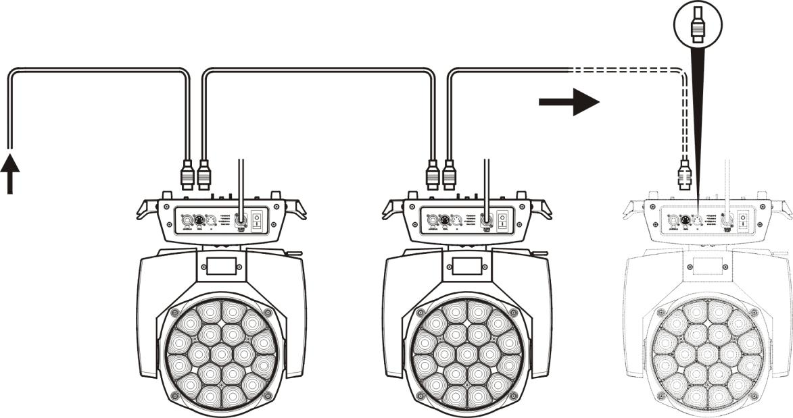
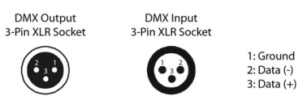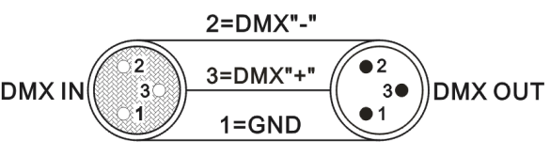

DMX-512 connections require a terminator (loop connection)
During the installation process, if the signal cable needs to be laid over a long distance or in a noisy environment, such as a karaoke bar, it is recommended to use a DMX terminal (loop connection). This helps prevent digital control signals from being muddied by electrical noise. The DMX terminal consists of a simple XLR connector with 2 or 3 pins and a 120-ohm resistor. Insert the terminal into the XLR output port of the last device, as shown in the figure below.
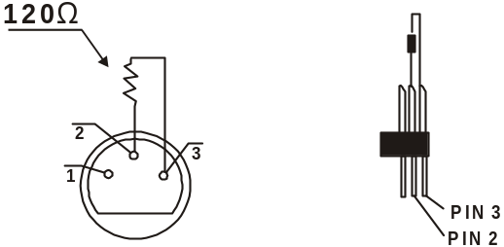

6. Menu description
- Menu desktop
temperature ：**℃
◆ Humidity: display the humidity of the board
◆**℃: Current temperature

humidity ：**

001
DMX-512 pattern

◆ Current address code

◆ Current operating mode

- Menu home screen
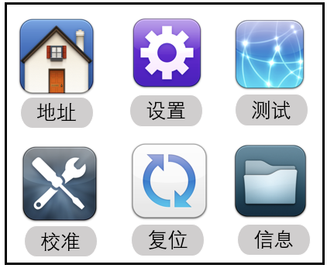

◆ Address: Click to enter the address code Settings
◆ Settings: Click to enter the system Settings
◆ Test: Click to enter manual mode
◆ Calibration: Click the input password to enter the system calibration mode
◆ Reset: Click to enter the system reset mode
◆ Information: Click to view system information

- Menu structure

primary menu | Sub-menu | Three-level menu/parameters
address | 001 - 512 | (Add or subtract one value)
 | running mode | DMX/self-walk 1/self-walk 1/sound control
 | channel pattern | 21CH/23CH/35CH/78CH/92CH/97CH/99CH
 | The level is reversed | On/off
 | Vertical reversal | On/off
 | Hall error correction | On/off
 | Light coupling error correction | On/off
 | Signal is maintained | On/off
 | Screen protection | On/off
 | The screen flips | On/off/automatic
 | Update synchronously | On/off
 | language | the Chinese language /EN
 | Screen lock | On/off
 | Speed mode | Fast / standard
 | factory data reset | affirm
 | factory data reset | cancel
manual mode | Current channel mode channel | 0-255
system calibration | enter password | Lamp calibration
system reset | The effect motor resets | affirm
system reset | Reset the scanning motor | affirm
system reset | All motors reset | affirm
system info | Reset error message | Display the reset error message
system info | DMX data monitoring | Receive the channel value from the console
system info | sensor information | Hall information
system info | sensor information | X-ray coupling information
system info | sensor information | Y optocoupler information
system info | Hardware version | Display the hardware version
system info | software release | Display the software version

- Automatic screen rotation function
The system can automatically rotate the screen according to the direction of gravity, without manual rotation. You can also turn off the automatic rotation function.

- manual control
This interface is used to control the current lamp.
Press "OK" to enter the editing state. Press "up" and "down" keys to change the channel value. Press "OK" again to save the modified value, exit the editing, press "exit" to not save the modified value, and directly exit the editing.

- system calibration
A password is set here to prevent non-professionals from misoperating. Press the "OK" key for password verification.
option | explain
Initial position calibration | After entering the sub-interface, you can adjust the reset position of the motor of X axis, Y axis, focusing and rotation to make up for the error in hardware installation. The adjustment range is 0~255, and 127 means no adjustment.
white balance | After entering the sub-interface, you can adjust the white balance of red, green, blue and white of the lamp and LED1-19. The adjustment range is 0~255, and 255 means no adjustment.
power | After entering the sub-interface, you can adjust the power of the lamp, and the adjustment range is 0~255.255 means no adjustment.
MIC sensitivity | Voice control sensitivity calibration.
Focus control | Control the focusing stroke, the adjustment range is 0~255,255 is the maximum value, 0 means no adjustment.
change password | Change the password entered in the system calibration interface.

- reset
Press the "up" and "down" keys to switch the reset mode, press "OK" and directly reset.
option | explain
The effect motor resets | The effect disk is reset except for XY
Reset the scanning motor | Only the XY axis is reset
All motors reset | Light fixture reset

- system info

option | explain
Reset error message | If the red ERR indicator light is on, it indicates that the lamp operation is wrong. You can enter the sub-interface to view the details.
DMX data monitoring | Thus, the sub-interface is entered to display the channel value numerically for viewing.
sensor information | Monitor the status of various photoelectric switches, Hall sensors and other sensors on the lamp in real time.
Hardware version number | Lighting hardware information.
Software version number | Lighting software version.

7. Product features
Voltage: AC90-240v 50-60HZ
Rated power: 760W
Light source: 19 high brightness LED beads of 40 watts (four-in-one RGBW)
Beam Angle: 5-55°
Strobe: 1-25 times per second with a variety of strobe effects
Dimming: 0-100% linear dimming.
Channels: 7 built-in channel modes 21CH/23CH/35CH/78CH/92CH/97CH/99CH
Control: DMX512, self-walking, voice control, RDM.
Horizontal scan: 540 degrees +16 bit fine tuning,
Vertical scan: 250 degrees +16 bit fine tuning
Display: Chinese and English display
Carton packing size (one and one): 62*39*51cm
Net weight 24kg, gross weight 26.7kg
characteristic ：
- Each lamp can be controlled separately.
- The unique honeycomb design of the lens can rotate infinitely to create a variety of dreamy effects.
- The display can automatically rotate 180° to accommodate different installation angles.
- It integrates multiple effects such as focusing, beam, staining and pattern into one.
- The scanning position memory function can be automatically reset.
- The system has the function of fan cooling and automatic temperature detection. When the temperature is too high, the system will automatically stop working to protect the lamp.

8. List of access points
channel |  |  | function | DMX numeric value | description
1 | 1 | 1 | red | 0-255 | Linear dimming from dark to light
2 | 2 | 2 | Red tweaks | 0-255 | Red 16bit dimming
3 | 3 | 3 | green | 0-255 | Linear dimming from dark to light
4 | 4 | 4 | Green tweaks | 0-255 | Green 16bit dimming
5 | 5 | 5 | blue | 0-255 | Linear dimming from dark to light
6 | 6 | 6 | Blue fine-tuning | 0-255 | Blue 16bit dimming
7 | 7 | 7 | white | 0-255 | Linear dimming from dark to light
8 | 8 | 8 | White fine-tuning | 0-255 | White 16bit dimming
9 | 9 | 9 | Color temperature adjustment | 0-255 | 8000K-2500K
10 | 10 | 10 | Color macro | 0-255 | 10-120 valid
11 | 11 | 11 | stroboflash | 0-255 | stroboflash
12 | 12 | 12 | General dimming | 0-255 | Linear dimming from dark to light
13 | 13 | 13 | General dimming fine tuning | 0-255 | Total dimming 16bit
14 | 14 | 14 | X axle | 0-255 | 0-540 degrees
15 | 15 | 15 | X-axis fine-tuning | 0-255 | 16-bit adjustable
16 | 16 | 16 | Y axle | 0-255 | 0-205 degrees
17 | 17 | 17 | Y-axis fine-tuning | 0-255 | 16-bit adjustable
18 | 18 | 18 | macro | 0-255
19 | 19 | 19 | reset | 0-25 | Reset and clear 0
 |  |  |  | 26-76 | The effect motor resets
 |  |  |  | 77-127 | XY motor reset
 |  |  |  | 128-255 | All motors reset
20 | 20 | 20 | amplify | 0-255 | The Angle is adjusted linearly from small to large
21 | 21 | 21 | revolve | 0-127 | 0-60 degrees
 |  |  |  | 128-188 | Counterclockwise from fast to slow
 |  |  |  | 189-193 | cease
 |  |  |  | 194-255 | Clockwise from slow to fast
 | 22 | 22 | LED1-R | 0-255 | LED1-Red dimming
 | 23 | 23 | LED1-G | 0-255 | LED1-Green dimming
 | 24 | 24 | LED1-B | 0-255 | LED1-Blue dimming
 |  | 25 | LED1-W | 0-255 | LED1-white dimming
 | 25 | 26 | LED2-R | 0-255 | LED2-Red dimming
 | 26 | 27 | LED2-G | 0-255 | LED2-Green dimming
 | 27 | 28 | LED2-B | 0-255 | LED2-Blue dimming
 |  | 29 | LED2-W | 0-255 | LED2-white dimming
 | 28 | 30 | LED3-R | 0-255 | LED3-Red dimming
 | 29 | 31 | LED3-G | 0-255 | LED3-green dimming
 | 30 | 32 | LED3-B | 0-255 | LED3-Blue dimming
 |  | 33 | LED3-W | 0-255 | LED3-white dimming
 | 31 | 34 | LED4-R | 0-255 | LED4-Red dimming
 | 32 | 35 | LED4-G | 0-255 | LED4-green dimming
 | 33 | 36 | LED4-B | 0-255 | LED4-Blue dimming
 |  | 37 | LED4-W | 0-255 | LED4-white dimming
 | 34 | 38 | LED5-R | 0-255 | LED5-Red dimming
 | 35 | 39 | LED5-G | 0-255 | LED5-green dimming
 | 36 | 40 | LED5-B | 0-255 | LED5-Blue dimming
 |  | 41 | LED5-W | 0-255 | LED5-white dimming
 | 37 | 42 | LED6-R | 0-255 | LED6-Red dimming
 | 38 | 43 | LED6-G | 0-255 | LED6-Green dimming
 | 39 | 44 | LED6-B | 0-255 | LED6-Blue dimming
 |  | 45 | LED6-W | 0-255 | LED6-white dimming
 | 40 | 46 | LED7-R | 0-255 | LED7-Red dimming
 | 41 | 47 | LED7-G | 0-255 | LED7-green dimming
 | 42 | 48 | LED7-B | 0-255 | LED7-Blue dimming
 |  | 49 | LED7-W | 0-255 | LED7-white dimming
 | 43 | 50 | LED8-R | 0-255 | LED8-Red dimming
 | 44 | 51 | LED8-G | 0-255 | LED8-green dimming
 | 45 | 52 | LED8-B | 0-255 | LED8-Blue dimming
 |  | 53 | LED8-W | 0-255 | LED8-white dimming
 | 46 | 54 | LED9-R | 0-255 | LED9-Red dimming
 | 47 | 55 | LED9-G | 0-255 | LED9-green dimming
 | 48 | 56 | LED9-B | 0-255 | LED9-Blue dimming
 |  | 57 | LED9-W | 0-255 | LED9-white dimming
 | 49 | 58 | LED10-R | 0-255 | LED10-Red dimming
 | 50 | 59 | LED10-G | 0-255 | LED10-Green dimming
 | 51 | 60 | LED10-B | 0-255 | LED10-Blue dimming
 |  | 61 | LED10-W | 0-255 | LED10-white dimming
 | 52 | 62 | LED11-R | 0-255 | LED11-Red dimming
 | 53 | 63 | LED11-G | 0-255 | LED11-Green dimming
 | 54 | 64 | LED11-B | 0-255 | LED11-Blue dimming
 |  | 65 | LED11-W | 0-255 | LED11-White dimming
 | 55 | 66 | LED12-R | 0-255 | LED12-Red dimming
 | 56 | 67 | LED12-G | 0-255 | LED12-Green dimming
 | 57 | 68 | LED12-B | 0-255 | LED12-Blue dimming
 |  | 69 | LED12-W | 0-255 | LED12-white dimming
 | 58 | 70 | LED13-R | 0-255 | LED13-Red dimming
 | 59 | 71 | LED13-G | 0-255 | LED13-Green dimming
 | 60 | 72 | LED13-B | 0-255 | LED13-Blue dimming
 |  | 73 | LED13-W | 0-255 | LED13-White dimming
 | 61 | 74 | LED14-R | 0-255 | LED14-Red dimming
 | 62 | 75 | LED14-G | 0-255 | LED14-Green dimming
 | 63 | 76 | LED14-B | 0-255 | LED14-Blue dimming
 |  | 77 | LED14-W | 0-255 | LED14-white dimming
 | 64 | 78 | LED15-R | 0-255 | LED15-Red dimming
 | 65 | 79 | LED15-G | 0-255 | LED15-Green dimming
 | 66 | 80 | LED15-B | 0-255 | LED15-Blue dimming
 |  | 81 | LED15-W | 0-255 | LED15-white dimming
 | 67 | 82 | LED16-R | 0-255 | LED16-Red dimming
 | 68 | 83 | LED16-G | 0-255 | LED16-Green dimming
 | 69 | 84 | LED16-B | 0-255 | LED16-Blue dimming
 |  | 85 | LED16-W | 0-255 | LED16-white dimming
 | 70 | 86 | LED17-R | 0-255 | LED17-Red dimming
 | 71 | 87 | LED17-G | 0-255 | LED17-Green dimming
 | 72 | 88 | LED17-B | 0-255 | LED17-Blue dimming
 |  | 89 | LED17-W | 0-255 | LED17-white dimming
 | 73 | 90 | LED18-R | 0-255 | LED18-Red dimming
 | 74 | 91 | LED18-G | 0-255 | LED18-Green dimming
 | 75 | 92 | LED18-B | 0-255 | LED18-Blue dimming
 |  | 93 | LED18-W | 0-255 | LED18-white dimming
 | 76 | 94 | LED19-R | 0-255 | LED19-Red dimming
 | 77 | 95 | LED19-G | 0-255 | LED19-Green dimming
 | 78 | 96 | LED19-B | 0-255 | LED19-Blue dimming
 |  | 97 | LED19-W | 0-255 | LED19-white dimming
channel |  | function | DMX numeric value | description
1 | 1 | red | 0-255 | Linear dimming from dark to light
2 | 2 | Red tweaks | 0-255 | Red 16bit dimming
3 | 3 | green | 0-255 | Linear dimming from dark to light
4 | 4 | Green tweaks | 0-255 | Green 16bit dimming
5 | 5 | blue | 0-255 | Linear dimming from dark to light
6 | 6 | Blue fine-tuning | 0-255 | Blue 16bit dimming
7 | 7 | white | 0-255 | Linear dimming from dark to light
8 | 8 | White fine-tuning | 0-255 | White 16bit dimming
9 | 9 | Color temperature adjustment | 0-255 | 8000K-2500K
10 | 10 | Color macro | 0-255 | 10-120 valid
11 | 11 | stroboflash | 0-255 | stroboflash
12 | 12 | General dimming | 0-255 | Linear dimming from dark to light
13 | 13 | General dimming fine-tuning | 0-255 | Total dimming 16bit
14 | 14 | X axle | 0-255 | 0-540 degrees
15 | 15 | X-axis fine-tuning | 0-255 | 16-bit adjustable
16 | 16 | Y axle | 0-255 | 0-205 degrees
17 | 17 | Y-axis fine-tuning | 0-255 | 16-bit adjustable
18 | 18 | macro | 0-255
19 | 19 | reset | 0-25 | Reset and clear 0
19 | 19 | reset | 26-76 | The effect motor resets
19 | 19 | reset | 77-127 | XY motor reset
19 | 19 | reset | 128-255 | All motors reset
20 | 20 | amplify | 0-255 | The Angle is adjusted linearly from small to large
21 | 21 | revolve | 0-127 | 0-60 degrees
21 | 21 | revolve | 128-188 | Counterclockwise from fast to slow
21 | 21 | revolve | 189-193 | cease
21 | 21 | revolve | 194-255 | Clockwise from slow to fast
22 | 22 | effect | 0-7 | Dimming mode
22 | 22 | effect | August 14 | Static effects (one effect per number)
22 | 22 | effect | 15-70 | Dynamic effects (one effect per number)
23 | 23 | Effect speed | 0-63 | cease
23 | 23 | Effect speed | 64-158 | The effect reverses from fast to slow
23 | 23 | Effect speed | 159-160 | The effect is paused
23 | 23 | Effect speed | 161-255 | The effect turns from slow to fast
24 | 24 | The effect fades | 0-255 | From fast to slow
25 | 25 | The effect is red | 0-255 | Red is linearly dimmed from dark to light
26 | 26 | The effect is green | 0-255 | The green is linearly dimmed from dark to bright
27 | 27 | The effect is blue | 0-255 | The blue is linearly dimmed from dark to light
28 | 28 | The effect is white | 0-255 | The white is linearly dimmed from dark to light
29 | 29 | Adjust the light | 0-255 | Effect foreground color dimming
30 | 30 | Background dimming | 0-255 | Adjust the background color of the effect
31 | 31 | The effect transitions | 0-255
32 | 32 | Effect enhancements | 0-255
33 | 33 | The prospects are flashing | 0-255 | The effect is frequent flashing
34 | 34 | Background strobe | 0-255 | The effect is to flash the scene
35 | 35 | background selection | 0-255
 | 36 | LED1-R | 0-255 | LED1-Red dimming
 | 37 | LED1-G | 0-255 | LED1-Green dimming
 | 38 | LED1-B | 0-255 | LED1-Blue dimming
 | 39 | LED2-R | 0-255 | LED2-Red dimming
 | 40 | LED2-G | 0-255 | LED2-Green dimming
 | 41 | LED2-B | 0-255 | LED2-Blue dimming
 | 42 | LED3-R | 0-255 | LED3-Red dimming
 | 43 | LED3-G | 0-255 | LED3-green dimming
 | 44 | LED3-B | 0-255 | LED3-Blue dimming
 | 45 | LED4-R | 0-255 | LED4-Red dimming
 | 46 | LED4-G | 0-255 | LED4-green dimming
 | 47 | LED4-B | 0-255 | LED4-Blue dimming
 | 48 | LED5-R | 0-255 | LED5-Red dimming
 | 49 | LED5-G | 0-255 | LED5-green dimming
 | 50 | LED5-B | 0-255 | LED5-Blue dimming
 | 51 | LED6-R | 0-255 | LED6-Red dimming
 | 52 | LED6-G | 0-255 | LED6-Green dimming
 | 53 | LED6-B | 0-255 | LED6-Blue color dimming
 | 54 | LED7-R | 0-255 | LED7-Red dimming
 | 55 | LED7-G | 0-255 | LED7-green dimming
 | 56 | LED7-B | 0-255 | LED7-Blue dimming
 | 57 | LED8-R | 0-255 | LED8-Red dimming
 | 58 | LED8-G | 0-255 | LED8-green dimming
 | 59 | LED8-B | 0-255 | LED8-Blue dimming
 | 60 | LED9-R | 0-255 | LED9-Red dimming
 | 61 | LED9-G | 0-255 | LED9-green dimming
 | 62 | LED9-B | 0-255 | LED9-Blue dimming
 | 63 | LED10-R | 0-255 | LED10-Red dimming
 | 64 | LED10-G | 0-255 | LED10-Green dimming
 | 65 | LED10-B | 0-255 | LED10-Blue dimming
 | 66 | LED11-R | 0-255 | LED11-Red dimming
 | 67 | LED11-G | 0-255 | LED11-Green dimming
 | 68 | LED11-B | 0-255 | LED11-Blue dimming
 | 69 | LED12-R | 0-255 | LED12-Red dimming
 | 70 | LED12-G | 0-255 | LED12-Green dimming
 | 71 | LED12-B | 0-255 | LED12-Blue dimming
 | 72 | LED13-R | 0-255 | LED13-Red dimming
 | 73 | LED13-G | 0-255 | LED13-Green dimming
 | 74 | LED13-B | 0-255 | LED13-Blue dimming
 | 75 | LED14-R | 0-255 | LED14-Red dimming
 | 76 | LED14-G | 0-255 | LED14-Green dimming
 | 77 | LED14-B | 0-255 | LED14-Blue dimming
 | 78 | LED15-R | 0-255 | LED15-Red dimming
 | 79 | LED15-G | 0-255 | LED15-Green dimming
 | 80 | LED15-B | 0-255 | LED15-Blue dimming
 | 81 | LED16-R | 0-255 | LED16-Red dimming
 | 82 | LED16-G | 0-255 | LED16-Green dimming
 | 83 | LED16-B | 0-255 | LED16-Blue dimming
 | 84 | LED17-R | 0-255 | LED17-Red dimming
 | 85 | LED17-G | 0-255 | LED17-Green dimming
 | 86 | LED17-B | 0-255 | LED17-Blue dimming
 | 87 | LED18-R | 0-255 | LED18-Red dimming
 | 88 | LED18-G | 0-255 | LED18-Green dimming
 | 89 | LED18-B | 0-255 | LED18-Blue dimming
 | 90 | LED19-R | 0-255 | LED19-Red dimming
 | 91 | LED19-G | 0-255 | LED19-Green dimming
 | 92 | LED19-B | 0-255 | LED19-Blue dimming

CH23 | CH99 | function | DMX numeric value | description
1 | 1 | X axle | 0-255 | horizontal control
2 | 2 | X-axis fine-tuning | 0-255 | Level fine-tuning control
3 | 3 | Y axle | 0-255 | vertical control
4 | 4 | Y-axis fine-tuning | 0-255 | Vertical fine-tuning control
5 | 5 | XY velocity | 0-255 | The horizontal/vertical speed is from fast to slow
6 | 6 | focus | 0-255 | focus
7 | 7 | tilting mirror | 0-127 | 0 to 60 degrees
7 | 7 | tilting mirror | 128-188 | Counterclockwise from fast to slow infinity
7 | 7 | tilting mirror | 189-193 | cease
7 | 7 | tilting mirror | 194-255 | Turn clockwise from slow to fast infinitely
8 | 8 | aiming | 0-255 | Linear dimming from dark to light
9 | 9 | stroboflash | 0-3 | light up
9 | 9 | stroboflash | 4-200 | The synchronous flicker speed is from slow to fast (1HZ-25HZ)
9 | 9 | stroboflash | 201-215 | Low speed random flash
9 | 9 | stroboflash | 216-234 | Medium speed random flashing
9 | 9 | stroboflash | 235-255 | High speed random flash
10 | 10 | red | 0-255 | Red is linearly dimmed from dark to light
11 | 11 | green | 0-255 | The green is linearly dimmed from dark to bright
12 | 12 | blue | 0-255 | The blue is linearly dimmed from dark to light
13 | 13 | white | 0-255 | The white is linearly dimmed from dark to light
14 | 14 | Color temperature adjustment | 0-255 | Linear color temperature adjustment
15 | 15 | Color macro | 0-255 | Built-in color gradient
16 | 16 | Static effects | 0-9 | not have
16 | 16 | Static effects | 10-14 | Static effect 1
16 | 16 | Static effects | 15-19 | Static effect 2
16 | 16 | Static effects | 20-24 | Static effect 3
16 | 16 | Static effects | ...
16 | 16 | Static effects | Five numbers make one effect
16 | 16 | Static effects | ...
16 | 16 | Static effects | 175-179 | Static effect 34
16 | 16 | Static effects | 180-184 | Static effect 35
16 | 16 | Static effects | 185-255 | Static effect 36
17 | 17 | Dynamic effects | 0-9 | not have
17 | 17 | Dynamic effects | 10-14 | Effect 1
17 | 17 | Dynamic effects | 15-19 | Effect 2
17 | 17 | Dynamic effects | 20-24 | Effect 3
17 | 17 | Dynamic effects | ... | ...
17 | 17 | Dynamic effects | Five numbers make one effect
17 | 17 | Dynamic effects | 220-224 | Effect 43
17 | 17 | Dynamic effects | 225-229 | Effect 44
17 | 17 | Dynamic effects | 230-255 | Effect 45
18 | 18 | Dynamic effect speed | 0-126 | The positive direction is from fast to slow
18 | 18 | Dynamic effect speed | 127-128 | static
18 | 18 | Dynamic effect speed | 129-255 | The reverse goes from slow to fast
19 | 19 | Background red | 0-255 | The background effect red is linearly dimmed from dark to bright
20 | 20 | Background green | 0-255 | The background effect is a linear dimming of the green color from dark to light
21 | 21 | Background is blue | 0-255 | The background effect is linearly dimmed from dark to light blue
22 | 22 | Background white | 0-255 | The background effect is linearly dimmed from dark to light
23 | 23 | reset | 0-26 | not have
23 | 23 | reset | 27-76 | The lamp head is reset for 5 seconds
23 | 23 | reset | 77-127 | XY reset is effective for 5s
23 | 23 | reset | 128-255 | Full reset is valid for 5 seconds
/ | 24 | R1 LED dimming | 0-255 | R1 LED dimming
/ | 25 | G1 LED dimming | 0-255 | G1 LED dimming
/ | 26 | B1 LED dimming | 0-255 | B1 LED dimming
/ | 27 | W1 LED dimming | 0-255 | W1 LED dimming
/ | … | … | …… | ……
/ | … | … | …… | ……
/ | 96 | R19 LED dimming | 0-255 | R19 LED dimming
/ | 97 | G19 LED dimming | 0-255 | G19 LED dimming
/ | 98 | B19 LED dimming | 0-255 | B19 LED dimming
/ | 99 | W19 LED dimming | 0-255 | W19 LED dimming

9. Product maintenance and cleaning
Please pay attention to the following points when testing this product:
- All screws and parts of the installed products must be tightly connected and not rust.
- The shell, lens, fasteners and installation locations (e.g. ceiling, bracket, truss, etc.) shall not deform.
- The mechanical moving parts should not be worn and should not rotate unbalanceably.
- The power cord should not be damaged in any way, such as material damage or scratches.
The installation and use of the products must be carried out by trained professional technicians to ensure that safety risks are eliminated.

In order to maintain the good condition of the product and extend its service life, we recommend regular cleaning of the product.
1. Clean the external lens and internal lens of the product every week to prevent the light output of the product from being weakened due to dust accumulation on the lens.
2. Clean the fan every week.
3. Professional electrical engineers shall conduct detailed circuit inspection on the products every three months to ensure good circuit joints and prevent aging of circuit joints due to overheating.
We recommend that the product should be cleaned regularly. Please note that do not use wet or linen cloth, and do not use alcohol or solvent for cleaning.
This product does not come with replacement parts. Please refer to the "Installation Instructions" section.
If you need any spare parts, please purchase them from your local dealer.

